# Display Tile Creator

What does “Tile Central” do?

Tile Central allow you to use a dashboard tile to display ANY attribute from ANY device

It also allows you to place text (including HTML tags) or an image into the same dashboard tile.

Install in the usual way by importing the code from the URLs below.

***Please note, the use of this App requires the virtual driver installing alongside. Further information on installing can be found on the Drivers page****.*

1st, create a virtual device and specify the ‘Display_Tile_Device’ as the driver/type

When the device is created, you can change the font weight and font colour

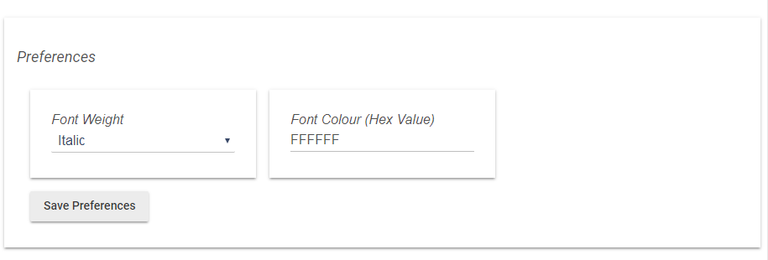

This example shows the device with an italic font in white, but you can any Hex colour code

Once the device is created, you can move on to configuring the app

Import the code in the usual way and install the parent app (Listed under User Apps as Display Tile Creator)

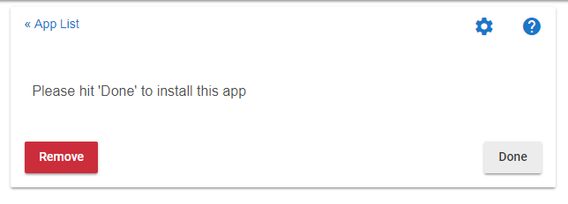

Next: Click “Add a new child automation”

When the next page opens..

Set the virtual Display Device (the virtual device you previously created)

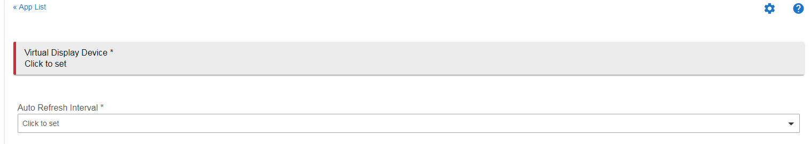

You will also need to select the Auto Refresh Interval

This is how often the device will send data to the dashboard tile

Below this you will see 8 buttons so you can configure each of the 8 available lines for your dashboard tile.

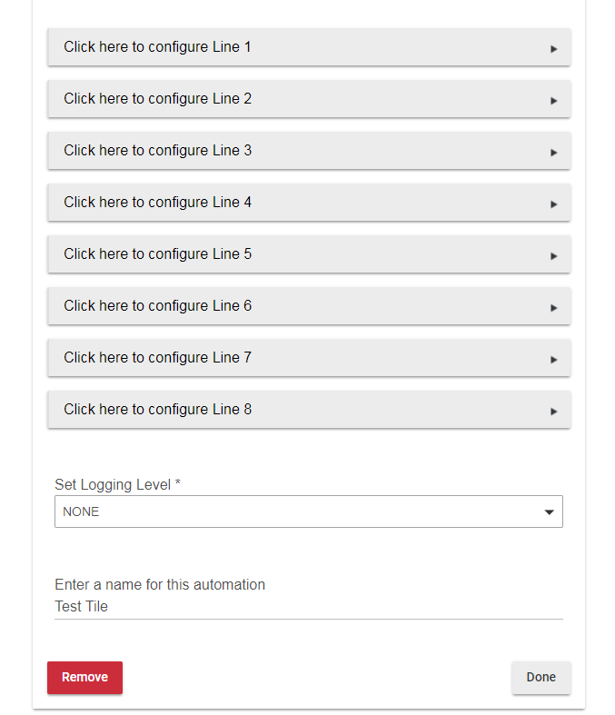

You can also set the logging level and enter a name for this child app

OK.

Now let’s look at some basic line configuration

Clicking on line 1 will show this screen:

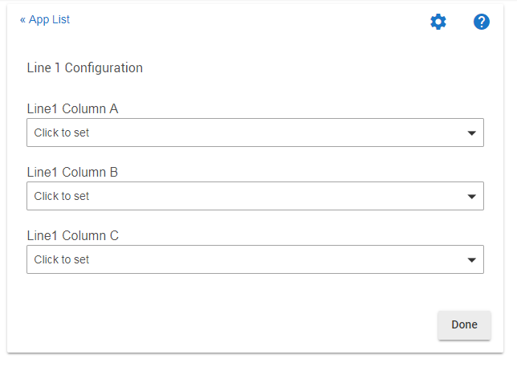

You now have the option to add up to 3 pieces of information on the tile.

Let’s look at Column 1 configuration.

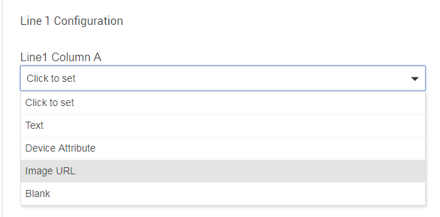

Here you have various options to display data in this position.

I’m going to select the ‘Image URL’ option

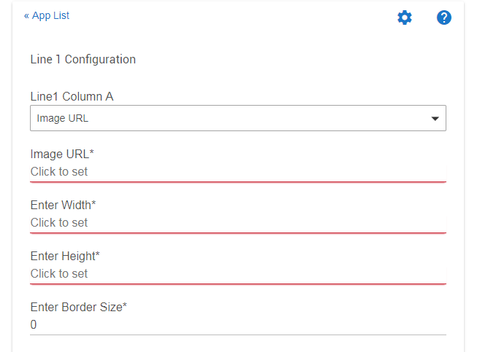

The options here are pretty obvious I think.

The URL must start with http:// or https:/

OK.. I’ve set my url and decided on a size that looks nice at the top of a 2x2 tile

If you don’t want anything else on this line Click ‘done’

Another line could show some text with a device attribute

Have a look at this:

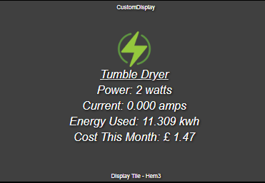

This particular tile uses attributes from a single device but it could just as easily be from multiple devices

After the icon, I have configured line 2 to show a heading (text entry) ‘Tumble Dryer’ and used HTML tags to underline it.

After you have configured your required number of lines, save the app and go to your dashboard

Create a new tile on the dashboard

The tile should use the ‘Attribute’ template

The device you need is the virtual display device you created earlier

The attribute you need is ‘CustomDisplay’

With a little playing, you could create something like this:

